**Miles Bennett**

**BSEE Candidate (2015)**

**MSEE Candidate (2016)**

**Magnetically Modulated Electrochemical Systems**



Magnetic field effects in electrochemical reactions can be divided into three categories: effects relating to mass transport, effects related to charge transfer, and effects related to deposition morphology in the electrode surface. The effects of magnetic fields on mass transport and deposition morphology are already well established; however, the effect of magnetic fields on charge transfer remains controversial. This current work is a systematic study of magnetic fields on the charge transfer process in a variety of electrochemical systems with strong magnetic coupling between the working electrode and electrolyte in solution. The results of this study not only will be of interest to scientists in the fields of physics and electrochemistry, but will see potential applications in: electrical engineering for use in magnetic sensor technology and low power electronics; materials science for use in new generations of fuel cells; and chemical engineering with uses in catalyst research.

Figure 1 Charge transfer can take place from any occupied energy state that is matched in energy with an unoccupied receiving state

Quantum Biomolecular Transducers for Electrochemical Sensing Applications

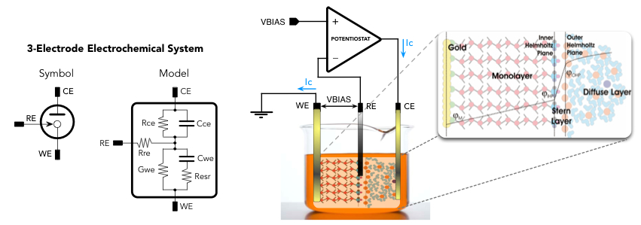

In this project, a marker-free biological sensor is proposed and investigated, wherein discrete electronic and vibrational modes of a molecular analyte can be determined via the electronic tunneling current as a transduction mechanism. Although similar systems based on quantum tunneling spectroscopy have been proposed previously, a biosensor of this type has yet to have been developed to function at room temperature environments. Noise is used as a gating mechanism to modulate the kinetics of charge transfer. A specialized low noise potentiostat is used in order to control both the interface voltage and the noise power in a typical three-electrode electrochemical cell. Current effects to improve the performance of the potentiostat focus on creating an ultra low-noise feedback loop and optimizing a transimpedance amplifier to measure sub-pA current levels.

Figure 2 A potentiostat in a three-electrode electrochemical cell. The potentiostat controls the potential difference between the working electrode (WE) and the reference electrode (RE) by injecting current into the counter electrode (CE).

Email: milesb1@stanford.edu